ROCKFALL STEP BY STEP
Hi, My name is Chelsea Leigh Pascua and this step-by-step tutorial is made for you so you can easily follow the complete process of creating and setting up a Unity space-shooter style game from scratch. Whether you're new to Unity or still learning how to organize scenes, UI, game objects, gameplay scripts, and managers, this guide walks you through every stage clearly and in order. Each step has been expanded with simple explanations so you’ll understand not just what to do, but why you’re doing it. By following this tutorial, you’ll be able to build a working project with a controllable spaceship, enemy objects, UI systems, effects, audio, and core gameplay logic that is all ready for testing and improvement. This guide is designed to remove confusion, help you avoid common mistakes, and give you a smooth start in building your game.

- Turn on your computer.
This is the first step before working on Unity or any development task. Make sure the machine is properly connected to power, and press the power button once. Wait for the system to boot completely. This ensures all necessary background processes, services, and hardware initializations are properly loaded.
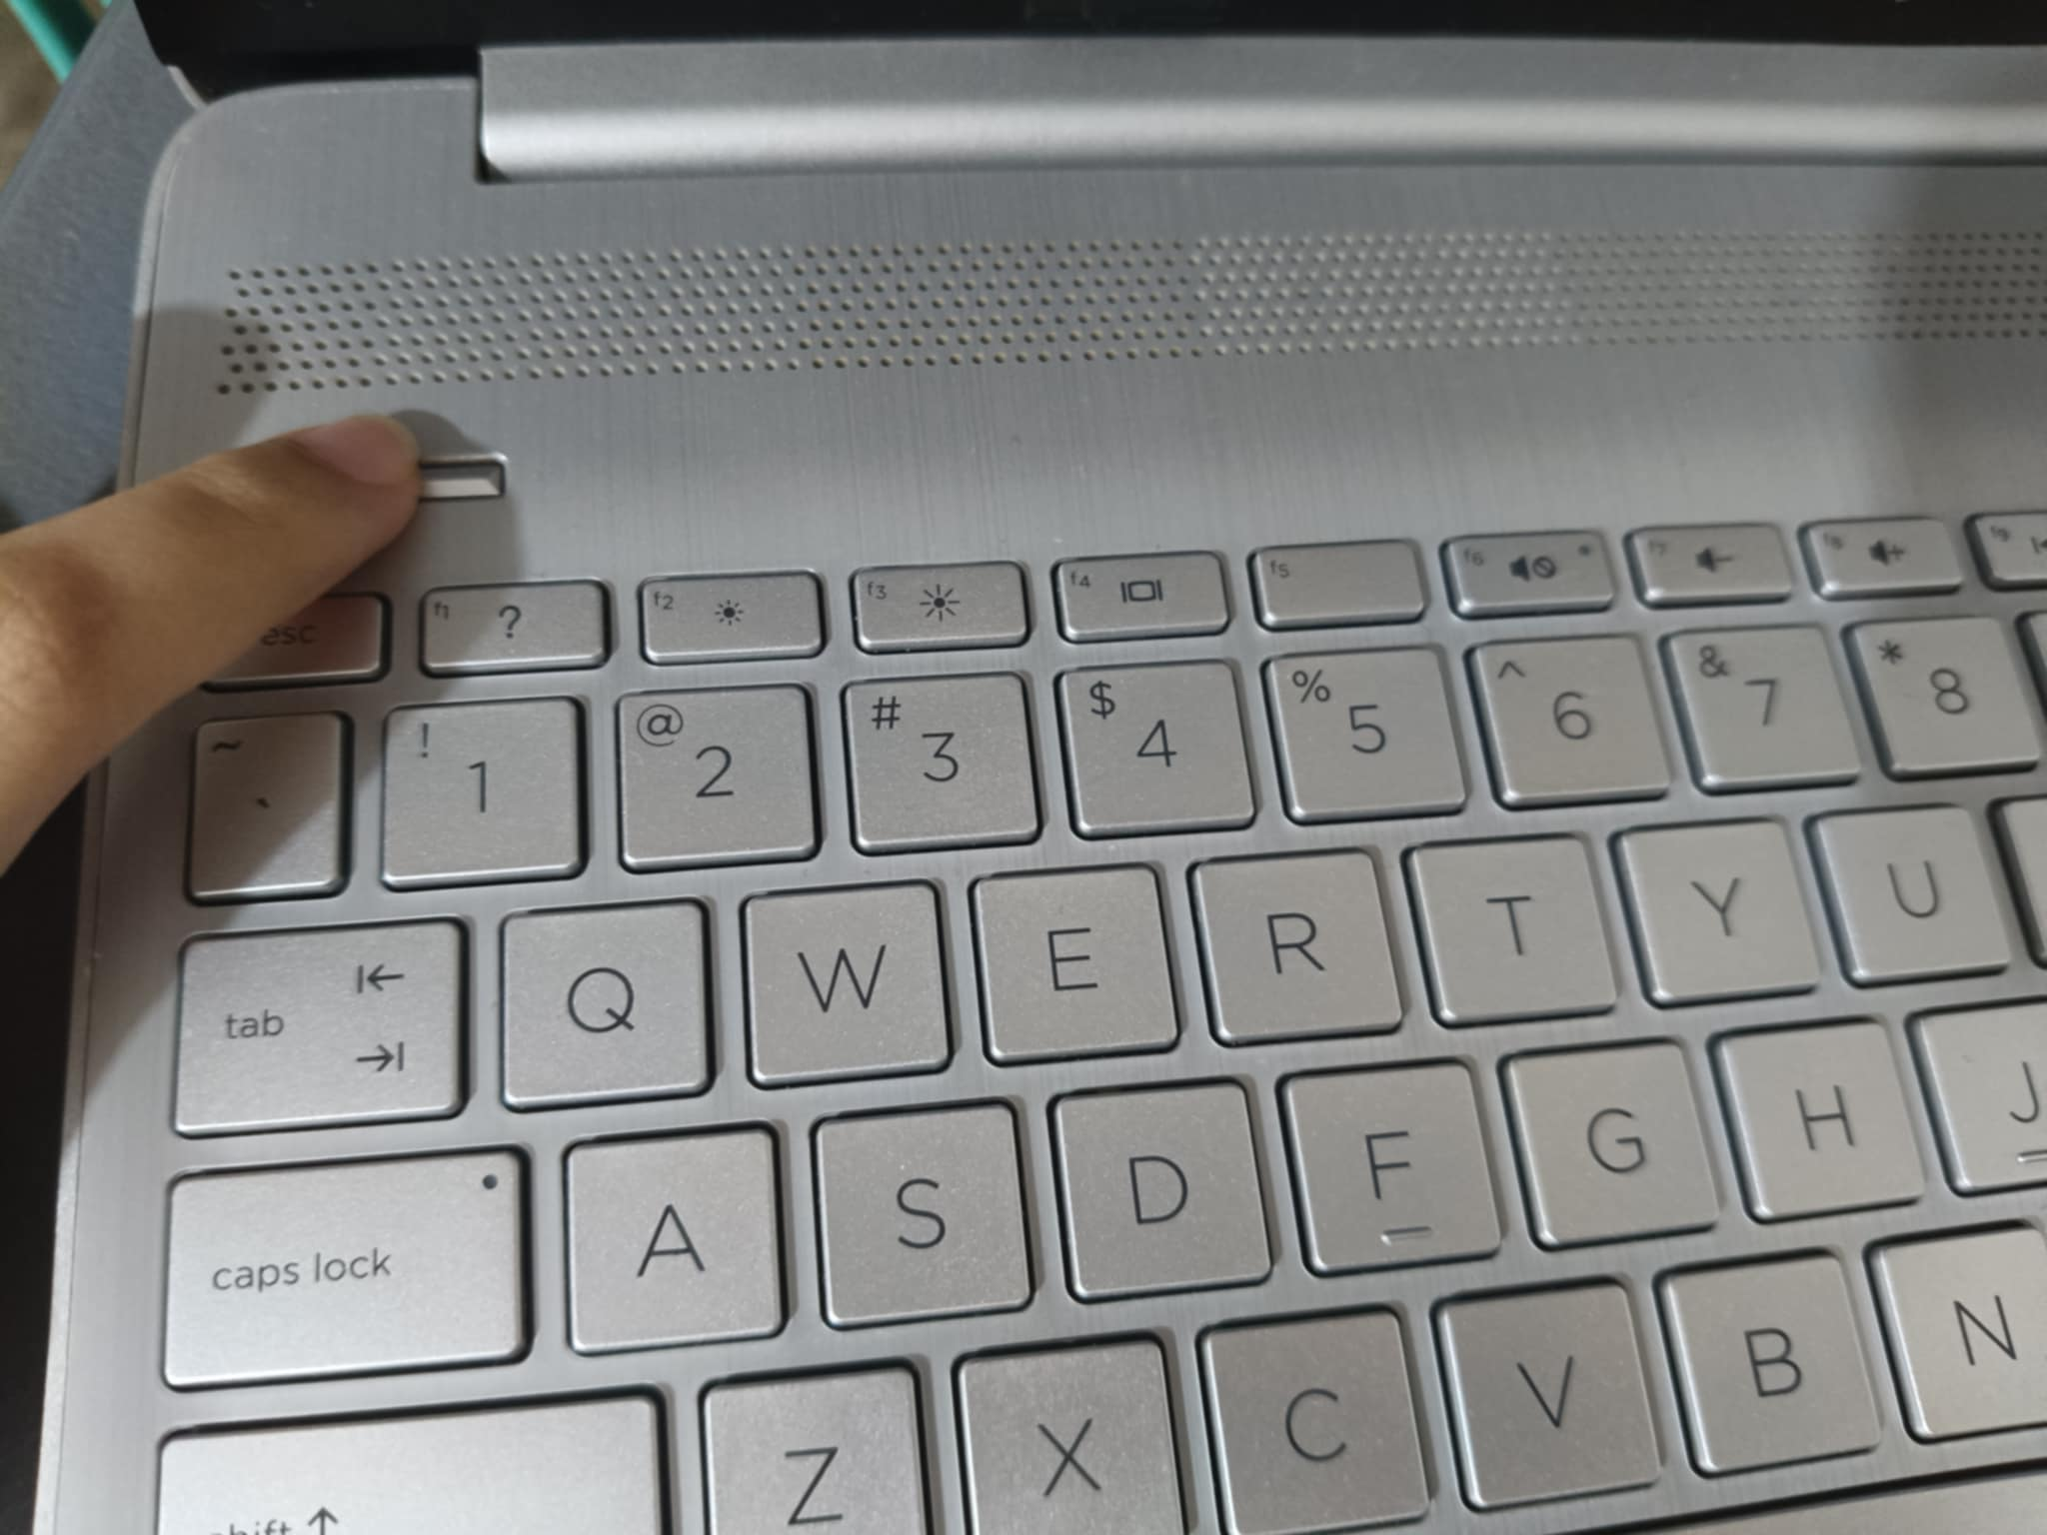
- Log in and wait for the desktop to load.
After the system boots, enter your account password or PIN. Allow the operating system to finish loading desktop icons, system tray applications, background tools, and essential drivers. This helps avoid launch delays or application startup issues later on.
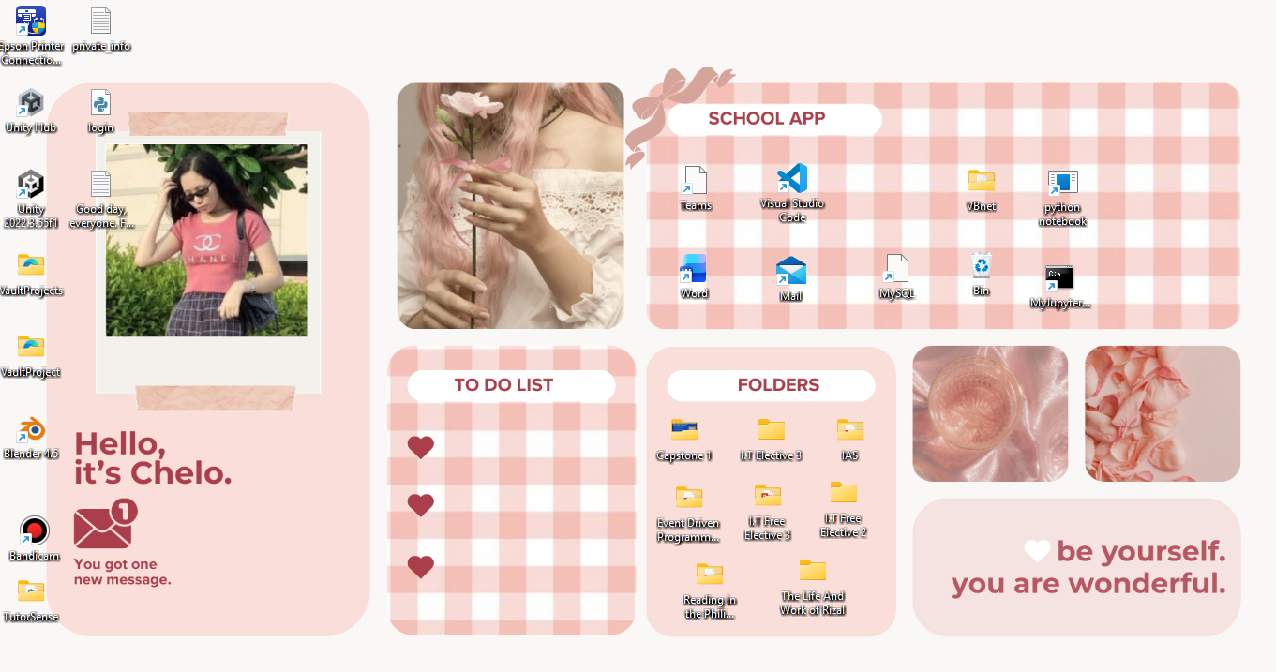
- Open the Unity Hub (double-click the Unity Hub icon).
Unity Hub is the main launcher for all Unity projects. It manages Unity versions, project templates, organization settings, and license activation.
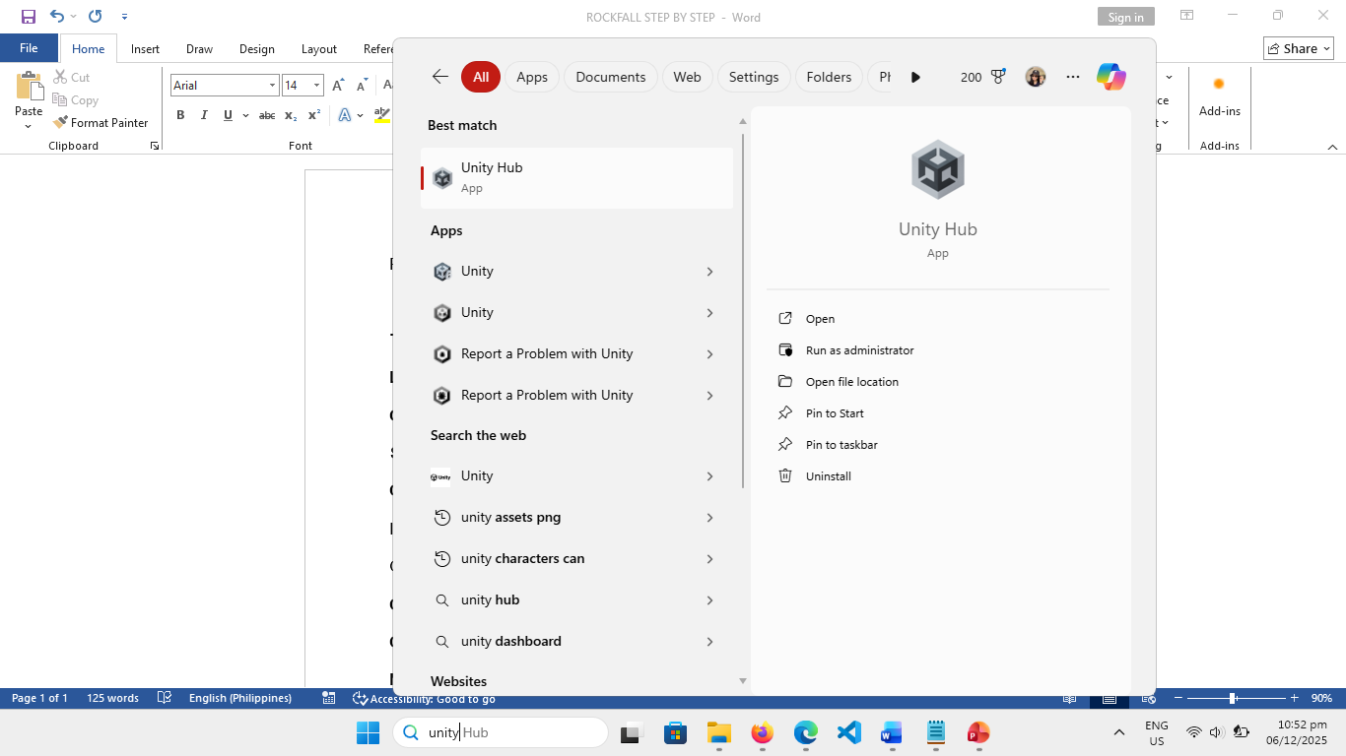

- Sign in to your Unity account if needed.
Some Unity features require your account login, including the Asset Store, cloud services, and project templates
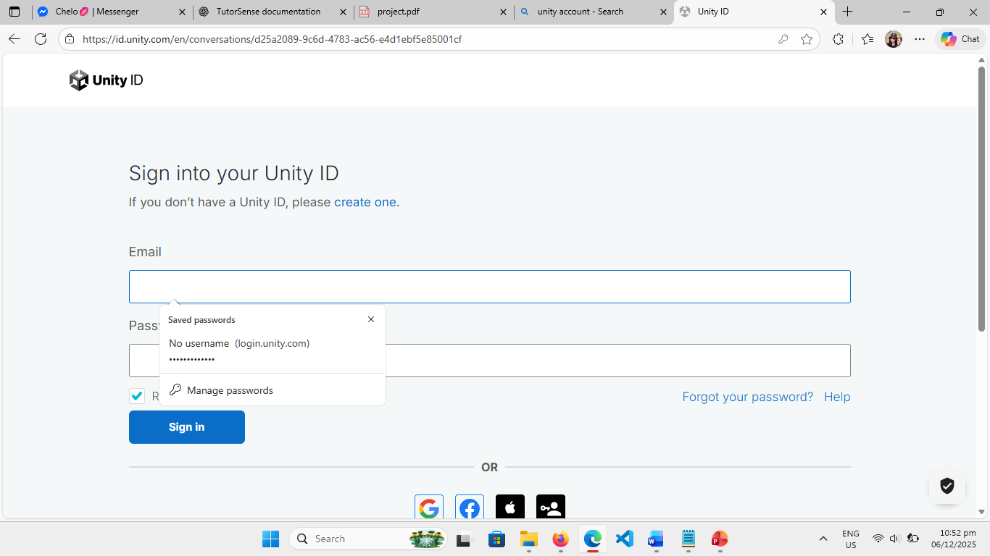

- Check your installed Unity versions in the “Installs” tab.
Make sure you have at least one compatible Unity Editor version. Different projects may require different versions.
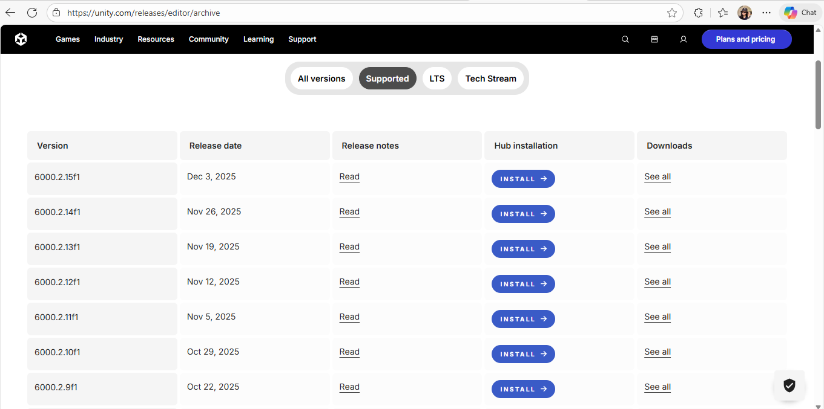
- If you don’t have a version installed, click “Install Editor” and choose one.
Select a stable LTS version for best compatibility. Unity Hub will automatically download and install it.
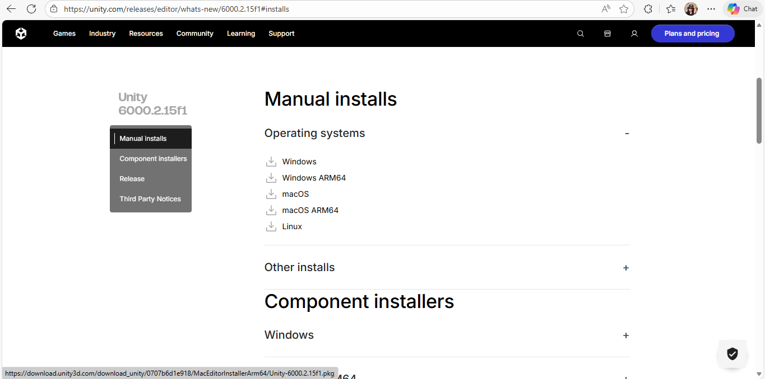

- Go to the Projects tab in Unity Hub.
This is where all your existing or new Unity projects are displayed.
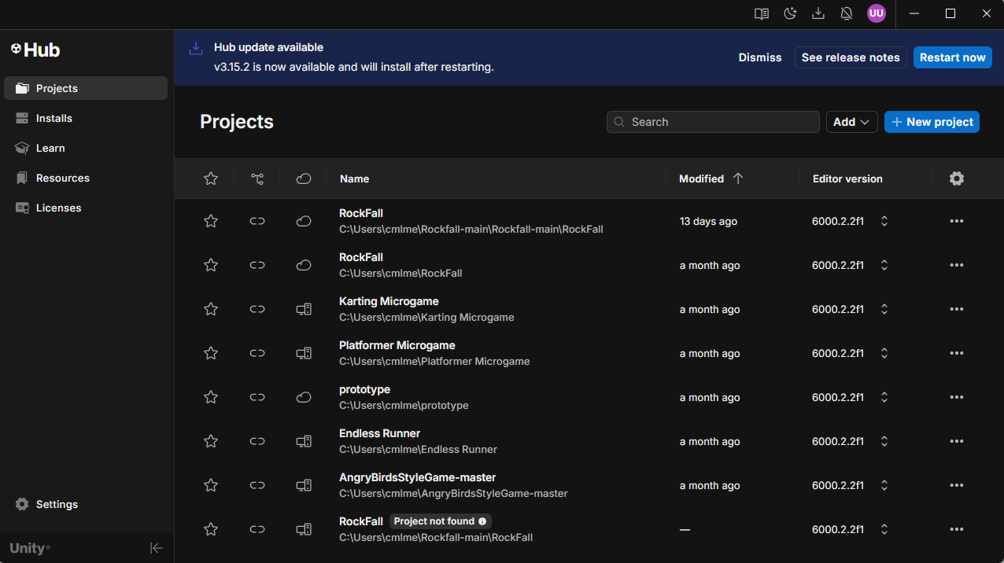
- Click “New Project” (top right or center button).
This begins the process of creating a fresh working project.
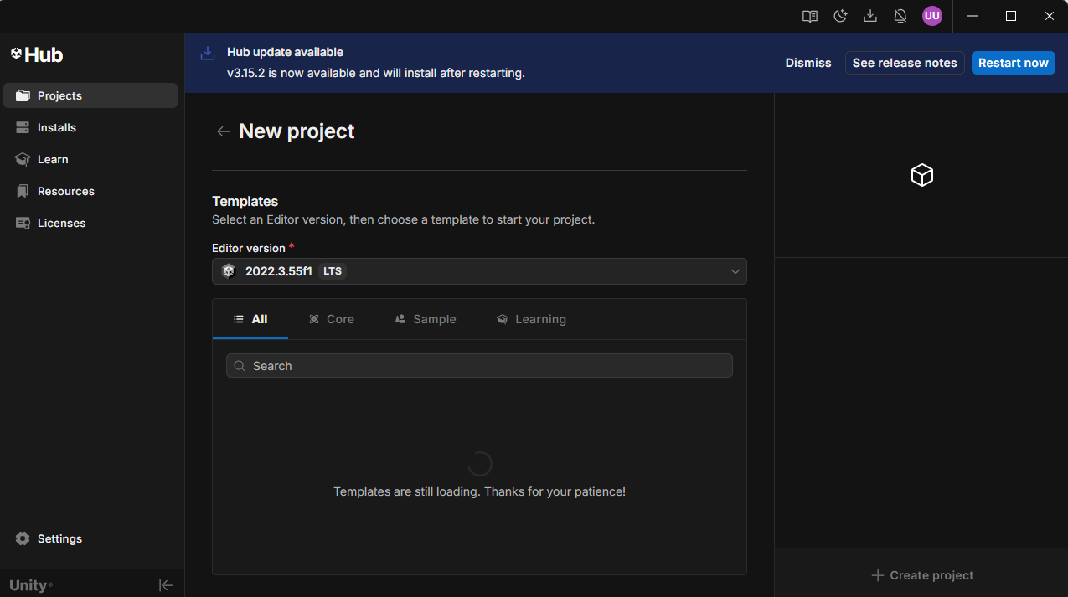
- Choose your project template (2D, 3D, URP, blank core, etc.).
Templates adjust default render pipelines and recommended project settings.
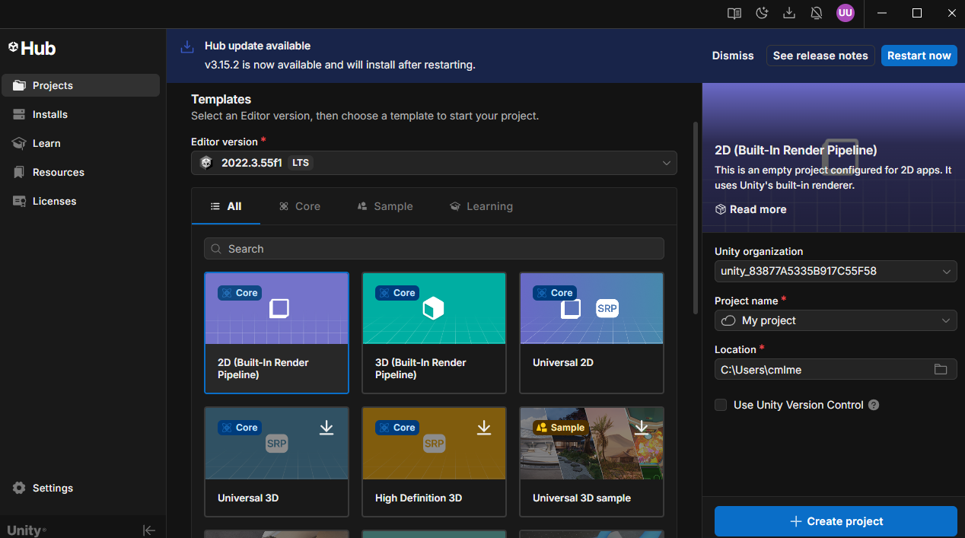

- Name your project in the text box.
Pick a clear and descriptive name which is the rockfall
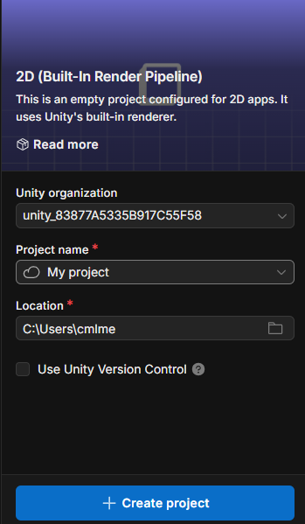

- Select your project save location by clicking the folder icon.
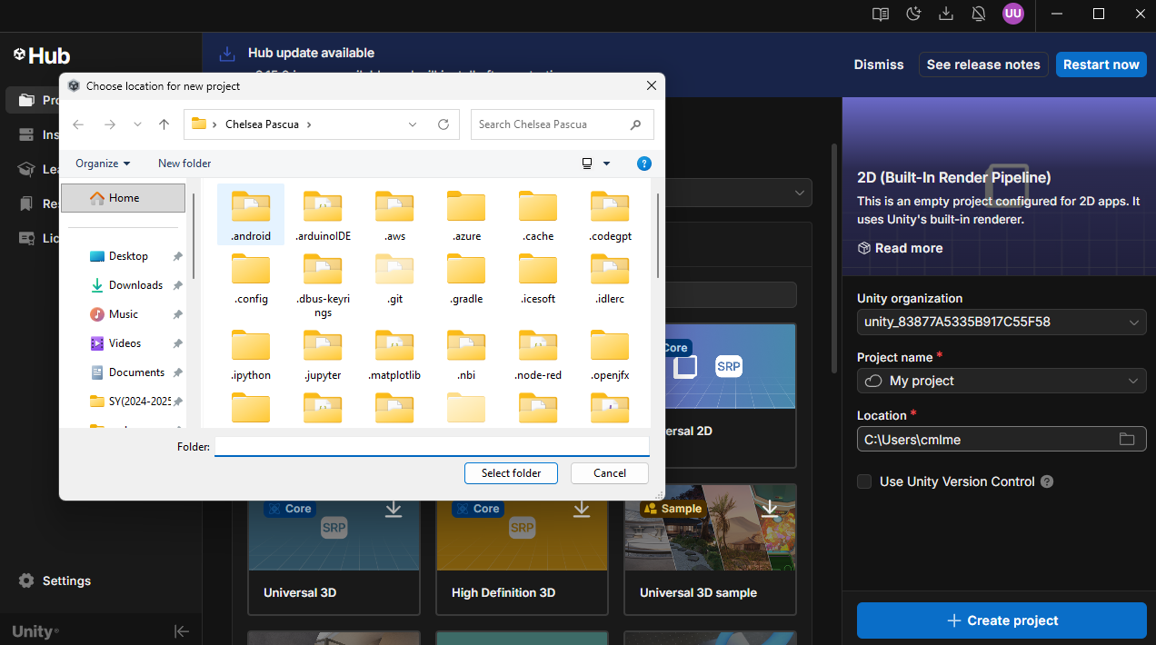
- Click “Create Project.”

Unity Hub will begin generating your project structure.
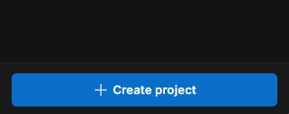

- Wait for Unity to load the editor and generate the project files.
Initial setup may take a few minutes, especially if importing templates or installing components.
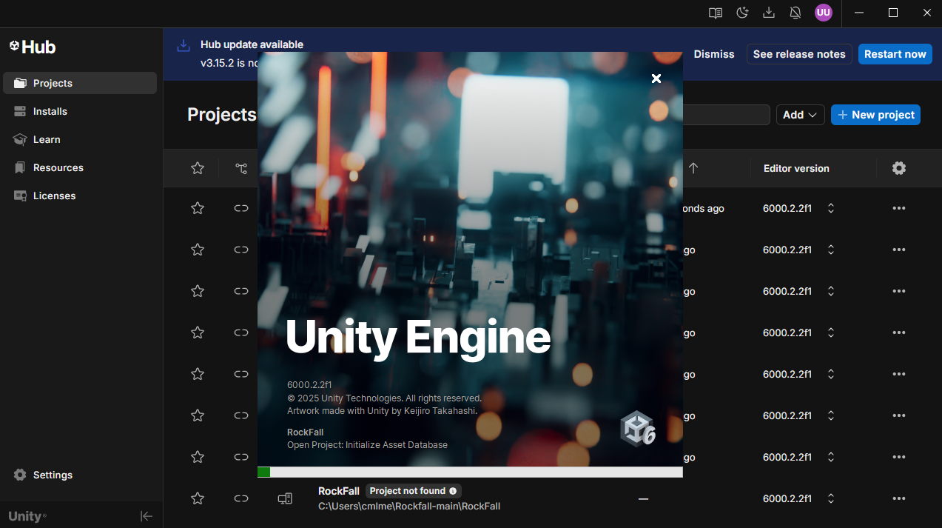
Now, let’s start with the main part!

14. Save the new scene
Saving the scene early is an important part of the workflow because it ensures that all the objects, lighting settings, UI elements, and environment configurations you have already made will not accidentally be lost if Unity crashes or if you close the project by mistake. After the project finishes loading for the first time, you go to the top menu bar and click File → Save As…. This allows you to choose a specific folder where your scene file will be stored. Inside the Unity project structure, the Assets folder is the proper place to save all scenes. Once you are inside the Assets folder, name your scene Main.unity. Giving scenes clear names helps you stay organized, especially when your project grows larger and contains multiple levels or UI scenes. After saving, Unity will now track changes in this scene file, and every time you press Ctrl+S, everything visually arranged in your hierarchy gets updated and stored safely.

15. Import the downloaded assets
Importing assets is essential because Unity needs these files—models, textures, prefabs, scripts, audio, and materials—to form the foundation of your gameplay and environment. When you have downloaded a .unitypackage file, simply double-click it from your file explorer. Unity will display a window showing all items contained in the package. You should select Import All to ensure nothing is left behind; missing assets can cause broken links, missing textures, or empty prefabs. Wait patiently while Unity processes the import because some packages include multiple large textures or models. Once the import completes, you will see the new folders and files appear in the Project window, usually under folders like Models, Prefabs, Textures, or Scripts. Having everything imported correctly gives you the foundation to place objects in your scene and build your game
world.

16. Create the ship object
The ship object is the main controllable character in your game, so setting it up correctly is crucial. Begin by creating an empty GameObject and rename it Ship. Place its Transform at the world origin (0, 0, 0) so it becomes easy to locate and manage. Then drag your spaceship model from the Assets folder and make it a child of the Ship object, or directly replace the empty object with the mesh. After that, add essential components: a Rigidbody so the ship has physics behavior, and a Collider (such as a BoxCollider or MeshCollider) so it can detect interactions with other objects. Disable gravity in the Rigidbody to simulate floating in space. Finally, attach your ShipController script. This script handles inputs, movement, turning, and possibly tilting. Modify the inspector values—such as moveSpeed, turnSpeed, tiltAmount, and smoothRotation—so the ship behaves smoothly and responsively during gameplay.

17. Make the camera follow the spaceship
A well-designed camera system is important for creating a good player experience. Start by creating an empty GameObject called CameraRig (or use the Main Camera directly). This rig helps organize camera behavior and adds flexibility if you want to include camera shake or cinematic movement later. Add your SmoothFollow script to the camera or rig. In the inspector, assign the Ship object as the follow target. Adjust properties such as distance, height, followSmoothness, and lookSmoothness so the camera remains behind the ship and moves smoothly without sudden jerking motions. Place the Main Camera under the CameraRig so it moves naturally as one unit. When you press Play, verify that the camera stays behind the ship, follows its motion, and rotates gradually while giving the player a clear view of the environment.

18. Create the space station
To create the main objective or central point in your space environment, drag your SpaceStation prefab into the scene and rename it properly. Position it somewhere noticeable, such as (0, 0, 50), so players can travel toward it. Add a Collider to detect impacts, and attach a DamageTaking script if the station is meant to take damage or be destroyed. You can assign hit points that match your game difficulty—e.g., 50 or more. If your game design includes spawning asteroids or enemies that aim toward the space station, this object can be marked as a target for the asteroid spawner. Setting up the space station properly makes the scene more dynamic and gives players an in-game purpose or destination.

19. Create or assign the skybox
A skybox defines the atmosphere and visual mood of your game, especially for space environments where stars and nebulae are essential. Go to Window → Rendering → Lighting, then scroll to the Environment section. Here you can assign a skybox material. If you don’t have one, create a new material using a procedural skybox or HDRI texture. Adjust rotation, exposure, and color values to match your preferred look. A good skybox adds immersion, depth, and realism to your game by surrounding the player with an infinite-looking space background instead of plain colored fog.

20. Create the canvas
Your UI begins with a Canvas because Unity renders all interface elements inside it. Create one by going to UI → Canvas and setting the Render Mode to Screen Space – Overlay, making your UI appear flat on the screen and always visible. Inside the canvas, add a TextMeshPro object to display the timer and anchor it to the top center. Then create other UI panels such as InGameUI, PausedUI, GameOverUI, GameWinUI, and MainMenuUI. Only the InGameUI should be active when gameplay begins, while the others remain inactive. Organizing the UI early helps avoid confusion later when wiring buttons and game state transitions.

21. Add the on-screen joystick
If your game is intended for mobile platforms, adding an on-screen joystick is essential for touch-based controls. Begin by creating a Panel under the canvas and rename it JoystickBG. Resize it to about 200×200 pixels and anchor it to the bottom-left corner so the player can easily reach it. Inside the panel, create an image named Thumb, which will represent the moving part of the joystick. Attach your VirtualJoystick script to the JoystickBG object. In the script’s inspector fields, assign the thumb reference and adjust sensitivity or radius settings to fit your desired control responsiveness. This allows the player to drag the thumb and generate directional input for the ship.

22. Create the joystick thumb visual
To make the joystick visually appealing and easy to understand, ensure the thumb image uses a circular sprite, giving it a recognizable analog-stick feel. Set its color to a semi-transparent white to avoid interfering with gameplay visuals. Adjust its RectTransform so it is centered and sized appropriately (such as 64×64). This thumb will move relative to the background panel, giving the player precise control input while ensuring it remains visually pleasing and responsive.

23. Create the input manager
An InputManager helps centralize all input-related logic in one place, making your project cleaner and more maintainable. Create a new empty GameObject called InputManager and attach your script. This script will act as a singleton, allowing other components like the ShipController to access input values through InputManager.Instance. In the inspector, assign your VirtualJoystick to the appropriate fields so the script knows where to read touch input from. This design keeps the control logic organized and scalable.

24. Link flight controls with gameplay scripts
Attach the ShipController (or equivalent movement script) to the ship object. Ensure that the InputManager instance is functioning and that the joystick is correctly referenced so the controller receives values from the on-screen controls. Test the setup in Play mode by dragging the joystick; the ship should rotate, tilt, and accelerate according to your script. This step is important because it verifies that your ship responds smoothly and accurately to player input, which is essential for enjoyable gameplay.

25. Create the in-game UI elements
Inside the InGameUI panel, create all interface elements players will rely on during gameplay. This may include health bars, score counters, and a more prominent timer display. Use TextMeshPro for text clarity, especially on mobile screens. Anchor UI elements strategically so they remain in safe zones even when switching to different aspect ratios or device resolutions. This ensures your HUD remains readable and consistent without being distorted or clipped.

26. Create the indicator container
For games in large or open environments, indicators help players locate distant objects. Create an empty GameObject called IndicatorContainer under the canvas. This container will store all off-screen or directional indicators your game requires. Keeping them grouped makes UI management easier and helps the IndicatorManager spawn new indicator icons in a consistent and organized manner.

27. Implement the indicator manager
Create a script named IndicatorManager and attach it to the canvas or a suitable UI controller. This script must maintain a list of objects to track—such as asteroids, objectives, or enemies—and convert their world-space positions into screen positions. It should automatically show the correct icon when an object is off-screen and hide or change color when the object is in direct view. By updating indicators every frame, this system helps guide players through the environment, preventing them from becoming lost.

28. Add weapon controls and targeting UI
Add a Fire button to the bottom-right area of the canvas to allow players to fire weapons using touch input. Next, create a targeting reticle at the center of the screen using an Image component with a crosshair sprite. The reticle can remain visible or appear only when aiming. Connect the Fire button’s OnClick event to your ShipWeapons.Fire() method so that pressing it spawns bullets. This step sets up the core combat interaction for your game.

29. Create the bullet prefab and weapon system
Begin by creating a new prefab for bullets called ShotPrefab. Add a visual component (SpriteRenderer or Mesh), a Rigidbody for physics, and a Collider (typically a SphereCollider set to trigger). Attach a DamageOnCollide script and assign a damage value, such as 1. Assign this prefab to your ShipWeapons script along with the fire points—child objects of the ship placed at the gun barrels. Test firing to ensure bullets spawn correctly, look visible, and travel in the intended direction.

30. Build the asteroid and damage system
Asteroids provide dynamic obstacles and targets in your game. Create an Asteroid prefab by combining a mesh with appropriate colliders and a Rigidbody. Add the DamageTaking and DamageOnCollide scripts to handle destruction and collisions. Set hit points for each asteroid and verify that bullets correctly reduce HP. Make sure at least one collider involved in collisions has a Rigidbody so Unity can detect the interaction. Test asteroid destruction to ensure they break and disappear as expected.

31. Implement menus, ship death, and explosion effects
Create your GameOverUI and GameWinUI panels with clear messages and buttons such as Restart. To enhance visual impact, create an explosion prefab using particle effects and assign an explosion sound. Set this explosion prefab in the DamageTaking script so that when an object is destroyed, the explosion automatically spawns. This adds feedback, realism, and excitement when enemies or the player ship are destroyed.

32. Set start points for spawning
Create two empty transforms named ShipStartPosition and SpaceStationStartPosition. Place them at the locations where you want these objects to appear at the start of the game. Assign these transforms to the GameManager so it knows where to spawn the ship and the station during game initialization. This makes restarting or reloading the game consistent and predictable.

33. Add the warning icon for boundary alerts
Create a UI Image called WarningUI under the canvas and assign a warning symbol. Disable it by default. This icon will appear when the ship approaches the boundaries of the play area. In the GameManager’s Update method, check the distance between the ship and the boundary. Activate the warning icon when the ship is outside the safe zone, and deactivate it once the ship returns.

34. Code the boundary system
Create a Boundary script or ScriptableObject containing values for warningRadius and destroyRadius. Create a Boundary GameObject at the center of your map and assign it to the GameManager. In your game logic, constantly check the ship’s distance from the boundary. If the ship crosses the destroyRadius, trigger GameOver. Display the warning UI when the ship crosses the warningRadius but is still within the allowed region. This creates tension and keeps the player within the intended play area.

35. Add trail renderers for ship and asteroids
Trail renderers add motion effects and visual clarity. Create a trail material and assign a glowing color. Under the ship, create two child objects positioned near the engines and attach TrailRenderer components. Adjust their time, width, and gradient settings so the trails fade smoothly. You can also add TrailRenderers to asteroid graphics for a dynamic streaking effect as they move through space. This greatly enhances visual appeal.

36. Add audio effects and background sound
Inside your Assets folder, create an Audio folder and import sound effects like engine hum, shooting, explosions, and background music. Create an AudioManager to organize playback. Assign an AudioSource to the ship for engine sounds and ensure it loops. For bullets, call AudioSource.PlayOneShot(fireClip). Attach explosion audio to the explosion prefab. Optionally, create an AudioMixer to control volume levels of music and SFX separately. Test all sound effects in Play mode to confirm they trigger at the right moments.

37. Integrate everything inside the GameManager
Make your GameManager a singleton so only one instance controls the game flow. Assign all necessary references in the inspector, including ship prefab, station prefab, UI panels, start positions, boundary object, warning UI, asteroid spawner, and camera followers. Implement methods such as StartGame, ShowMainMenu, GameOver, and GameWin. Ensure StartGame triggers the timer and properly resets UI elements. When the player wins or loses, stop the timer and activate the correct UI panels.

38. Final testing and verification
Press Play in the Unity Editor and perform a full test. Move the on-screen joystick to confirm the ship moves smoothly and responds to user input. Test firing and ensure bullets spawn correctly and destroy asteroids. Wait for the timer to expire to check if GameWin UI displays. Collide the ship with an asteroid to trigger GameOver. Finally, test all UI buttons like Restart or New Game and confirm that everything resets properly—including ship position, UI visibility, timer, audio, and game state. Ensuring all systems work consistently prepares your game for final polish and deployment.

The End

By following all the steps in this guide, you have successfully built the core structure of a fully interactive Unity game and complete with movement systems, UI management, object interactions, damage logic, audio feedback, and overall game flow handled by the GameManager. Each section you completed contributed to the foundation of a functional gameplay experience, from the simple creation of prefabs and UI elements all the way to integrating input systems, spawn points, boundaries, and effects.
At this point, your project should be in a playable state, and you should already see how the different systems complement one another to form a cohesive game. The progress you’ve made is not only technical but it reflects a deeper understanding of Unity’s workflow, hierarchy management, scripting architecture, and user interface design. These skills will serve as a strong base for future projects, whether you choose to expand this game further or begin a completely new one.
Remember that game development is always iterative. The version you have now is your foundation to something you can polish, optimize, expand, and improve through time. You can add new mechanics, upgrade visual effects, refine controls, introduce more UI screens, or add new enemies and gameplay challenges. Every improvement you make will build on the solid structure you’ve already created.
Most importantly, enjoy the process. Game development is both creative and technical, and the best results come from experimenting, trying new ideas, and learning through every build, bug, and breakthrough. As long as you continue exploring and improving your craft step by step just like you did in this guide, you’ll keep growing into a stronger and more confident developer.
Congratulations on completing this tutorial, and keep building. Your next great project is waiting.

